**EXAMINATION MANAGEMENT SYSTEM IN JAVA**

**Pronay Kumar Ghosh**

Department of Electronics & Communication Engineering,

Techno Engineering College, Banipur, Habra – 743233, WB, India

***Abstract*** – *This report is an attempt to describe and discuss about the Examination Management System Project, implemented by dynamic and powerful technology software called IntelliJ IDEA for JAVA foundation. This project is helpful for students to practice different mock examinations from this software. In current generation lots of examinations like GRE, CAT, MAT…etc. is conducted through this kind of examination management systems. This project will help students to get practice to examination method by taking mock test from this software. Students examination module helps them to register with application and give the examination on desired courses and get the result of their own performance.*

***Keywords****: Examination Management System, JAVA, OOPS concept, GUI Software, XAMPP server, MySQL Database, Computer based examination, MCQ test, Timer based exam, Result showing, Negative marking.*

1. **INTRODUCTION**

In formal education system, examination is the widely accepted method of evolution of students. Every school, university or any academic institute organizes formal examination to major the knowledge and skills of its student gained during academic session. But, the current examination system is traditional and is not so effective. This online examination management system project is a proposal for a new system for taking and giving exams.

Examination Management System is an application developed in java programming language. You can get the complete java software, project report, documentation and other necessary project files of this project & use this as your exam management system.

In the existing system, all works are done manually. There are chances of committing errors and it will take more time to perform any transaction. There are so many limitations in the existing system. If the system is carried over manually for every transaction it will take more time making it difficult to take immediate decisions. The online application creates an inter-link among three modules of this software: Login, Sign Up, Examination Portal. In this Examination Management System, user implies to the students who take exam. Administration is the one who maintains the information and data of the registered users. Institutions can not directly register in the system but they set questions and answers.

The proposed system overcomes all the drawbacks of the existing examination system. Being an application, it can be accessed from anywhere. It is a fast, efficient and economical.

1. **Examination Management System Details**
2. **LOGIN PAGE**

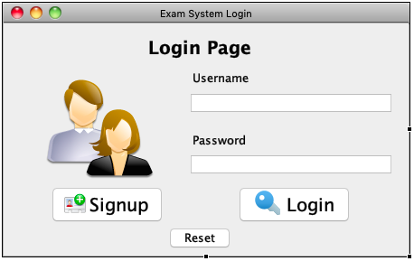**Starting Page**

Write your username, password, and press login to enter to the exam portal.

Otherwise click on Signup to create new account.

Press Reset to reset the form.

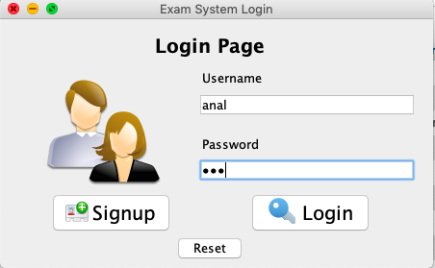

**Input Details**

Write your username, password, and press login to enter to the exam portal.

Otherwise click on Signup to create new account.

Press Reset to reset the form.

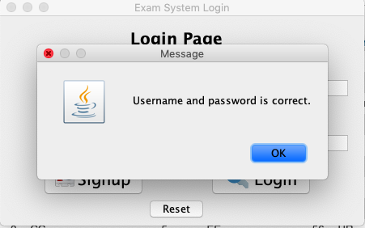

**Details Verified**

Your username, password, and press login & details will be verified to enter to the exam portal.

Go to the Exam portal to give exam after successful login.

Press Reset to reset the form.

1. **SIGN UP PAGE**

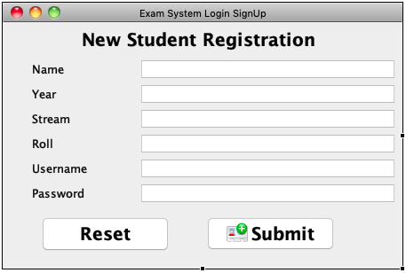

**Sign Up Here**

Write all your details like username, password, Name, Year, Stream, Roll and press submit to register to the database of exam portal.

Press Reset to reset the form.

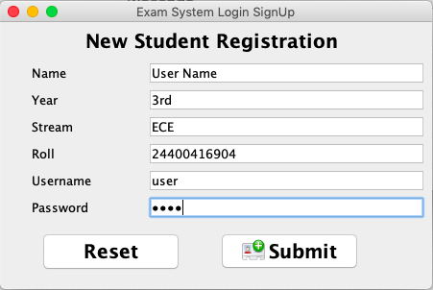

**Input Details**

After filling up all your details like username, password, Name, Year, Stream, Roll and press submit to register to the database of exam portal.

Press Reset to reset the form.

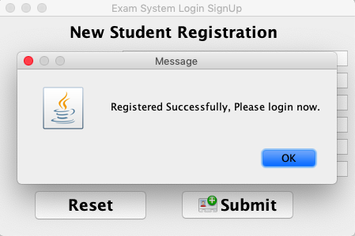

**Registration Successful**

After successful registration press OK.

1. 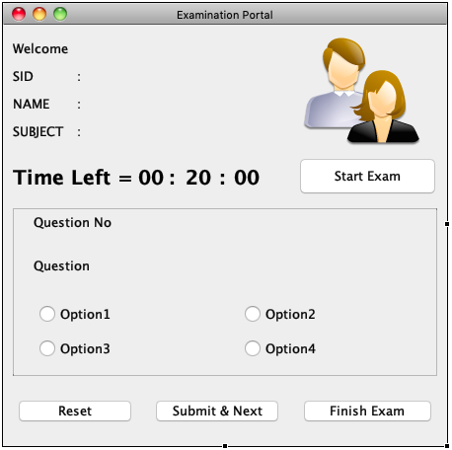**EXAMINATION PORTAL**

**Blank Examination Portal**

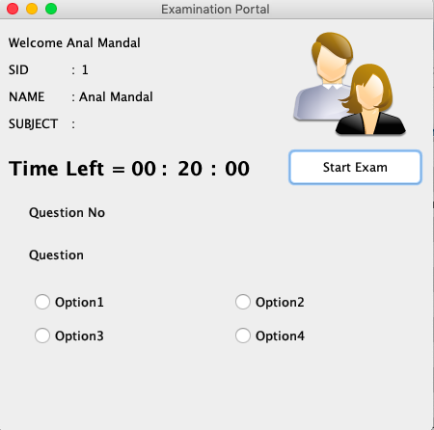

**Logged in Portal**

After successful login Name & ID should appear in the portal. Now press Start Exam to start the examination.

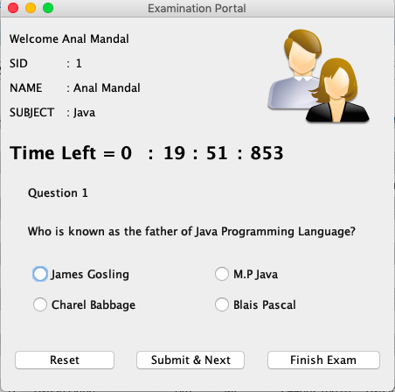

**Choose Correct Answer**

Choose correct answer of the questions from the given 4 MCQ options, if the answer is correct then you’ll get a message of correct response and calculated marks. Press OK to continue.

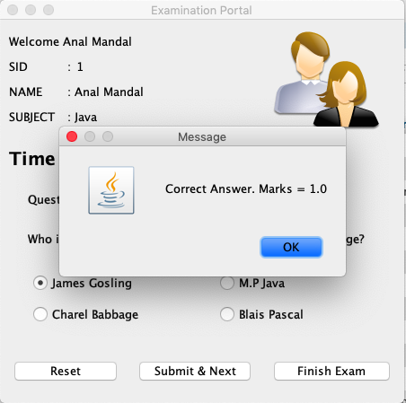

**Correct Answer**

If the answer is correct then you’ll get a message of correct response and calculated marks. Press OK to continue.



**Wrong Answer**

If the answer is wrong then you’ll get a message of wrong response and calculated marks. Press OK to continue.



**Finish Exam**

If you want to finish the exam then click Finish Exam, if the answer is correct then you’ll get a message of correct response and calculated marks. Press OK to Quit.

1. **HARDWARE & SOFTWARE USED**

Hardware : Lenovo ideapad300

Operating System : Windows 10

Software : IntelliJ IDEA, XAMPP Server

Programming Language : JAVA 9, MySQL

Database : MySQL Database

1. **FUTURE SCOPE**

In this section, we would like to elaborate what we wished to further include in the project, but was unable to do so due to time constraints.

1. **FORGOT PASSWORD + CHANGE PASSWORD**

After some time if someone has forgotten the password of his/her account, then we should give them the option to reset their password using their credentials. The Login table would have to be updated with the contact information of the new password of the user.

The existing user who wants to change their password they will get an option to change their password.

1. **SEARCH BAR:**

This represents the most ambitious part of the project during the design phase. The search bar would allow the user in the user/admin page to type keyword and upon clicking a submit button, the resulting affect would be a redirection to a new page, with results from a complete scan of the entire database that holds various tables corresponding to different information. All results would be displayed in the form of tables, giving the user the complete freedom to choose how he/she would like to access the information depending on their particular needs. As a future scope for this project, we believe that the ‘search bar’ would definitely distinguish itself as a standout feature for this project.

1. **ADMIN SECTION:**

We want to add a separate section only accessible for the admins, in that section an admin can go through each & every details of all activities and admin can monitor them.

1. **ADMIN COURSE ENTRY PANEL:**

Inside Admin section, admin can add/remove any course according to their need.

Admin can conduct an examination, after successful completion of that examination he/she can remove the course from their course list.

1. **FEEDBACK FORM TO THE ADMIN:**

After logging in, the user would should have a dedicated section in this application to communicate with the admins. This will be achieved by have a two-textbox, submit and reset button combination. The first textbox, illustrating the topic of the feedback, with regard to the application the user is currently using. The second textbox, slightly larger in nature would allow the user to convey his/her message to the admin. Upon submitting the feedback form, the admin would get a notification, when logging into the database the following time.

1. **RESULT VIEW & PRINT:**

In this section an user can view their final marks in a Marksheet/Result format. They

can print if they wish to print the result as a document.

1. **EXTEND ADMIN PRIVILEGES FOR THE ENTIRE PROJECT:**

The only privileges that we were able to design and implement, were the insert and update sections for the user/admin homepages. An essential aspect regarding the future scope of the project would be, to not only include the code for deleting topics but also extending the concept of the privileges (i.e. inserting, updating, deleting data) admin would have in a project such as this to the entire database.

1. **CONCLUSION**

To sum it up, this online Examination Management System in Java mainly focuses on taking examination without pen and paper. In the proposed system, with minimum cost, time and man power, examination can be conducted and this can prove to be very effective overall. New features and module can be integrated into the system as per user requirements in future…

1. **REFERENCES**
2. JAVA – The Complete Reference – Ninth Edition by Herbert Schildt [Oracle Press].
3. <https://www.academia.edu/10434039/Student_Java_Online_Documentation_Advanced_Java_Project_>
4. **ACKNOWLEDGEMENT**

Success is the manifestation of diligence, perseverance, inspiration, motivation and innovation. A successful project is a fruitful culmination of efforts of many people, some directly involves while other that have quietly encouraged and extended their support while being in the background.

We are grateful to Mrs. Sulekha Das (JAVA lecturer and project supervisor) not only for her invaluable guidance but also for her unending encouragement that she has given to us throughout the JAVA course and project. This work reflects her teachings and expertise in the subject that she has passed on to us. This course and project have been challenging and most enthralling experience. We sincerely thank her for her patience, humor and knowledge, and hope to continue forward to better and more exciting days with our careers.

As I, Pronay Kumar Ghosh am submitting this documentation. I declare that the above acknowledgement and this documentation along with this project: ‘Student Exam Management System in Java’ in its entirety is truthful, honest.